1 run

training 1 epoch...

237.91159081459045 seconds used......

1 training finished! average train loss: 0.612410978323719

evaluating...

Confusion matrix, without normalization

[[ 687 196 139]

[ 708 4586 113]

[1248 355 9162]]

Normalized confusion matrix

[[0.67221135 0.19178082 0.13600783]

[0.13094137 0.84815979 0.02089883]

[0.11593126 0.03297724 0.8510915 ]]

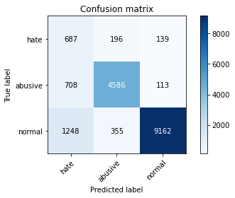

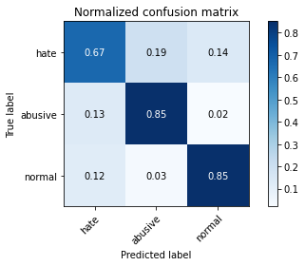

precision recall f1-score support

hate 0.26 0.67 0.37 1022

abusive 0.89 0.85 0.87 5407

normal 0.97 0.85 0.91 10765

accuracy 0.84 17194

macro avg 0.71 0.79 0.72 17194

weighted avg 0.91 0.84 0.86 17194

average eval_loss: 0.4630620037227176, accuracy: 0.8395370478073747

training 2 epoch...

237.24128794670105 seconds used......

2 training finished! average train loss: 0.44438747271189033

evaluating...

Confusion matrix, without normalization

[[ 609 248 165]

[ 513 4760 134]

[ 863 417 9485]]

Normalized confusion matrix

[[0.59589041 0.24266145 0.16144814]

[0.09487701 0.8803403 0.02478269]

[0.08016721 0.03873665 0.88109614]]

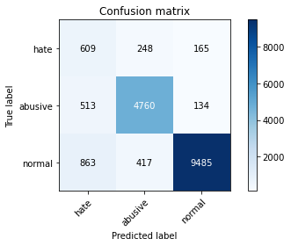

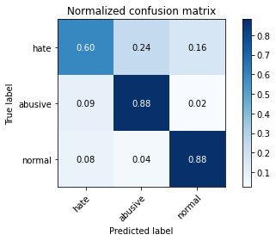

precision recall f1-score support

hate 0.31 0.60 0.41 1022

abusive 0.88 0.88 0.88 5407

normal 0.97 0.88 0.92 10765

accuracy 0.86 17194

macro avg 0.72 0.79 0.74 17194

weighted avg 0.90 0.86 0.88 17194

average eval_loss: 0.39198507373762687, accuracy: 0.8639060137257183

training 3 epoch...

237.31963467597961 seconds used......

3 training finished! average train loss: 0.3322020022379356

evaluating...

Confusion matrix, without normalization

[[ 648 198 176]

[ 746 4466 195]

[ 948 274 9543]]

Normalized confusion matrix

[[0.63405088 0.19373777 0.17221135]

[0.1379693 0.82596634 0.03606436]

[0.08806317 0.02545286 0.88648398]]

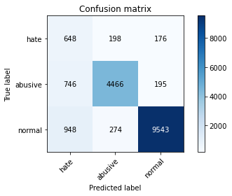

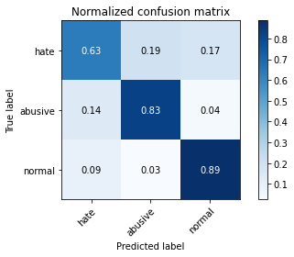

precision recall f1-score support

hate 0.28 0.63 0.39 1022

abusive 0.90 0.83 0.86 5407

normal 0.96 0.89 0.92 10765

accuracy 0.85 17194

macro avg 0.71 0.78 0.72 17194

weighted avg 0.90 0.85 0.87 17194

average eval_loss: 0.44592061775714853, accuracy: 0.8524485285564732

training 4 epoch...

237.36149334907532 seconds used......

4 training finished! average train loss: 0.22386766818791426

evaluating...

Confusion matrix, without normalization

[[ 677 181 164]

[ 928 4284 195]

[1330 279 9156]]

Normalized confusion matrix

[[0.66242661 0.17710372 0.16046967]

[0.17162937 0.79230627 0.03606436]

[0.12354854 0.02591732 0.85053414]]

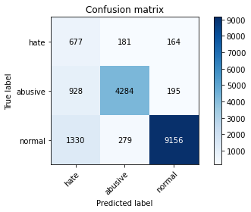

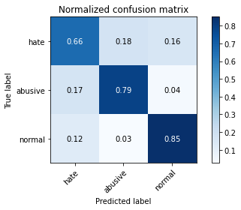

precision recall f1-score support

hate 0.23 0.66 0.34 1022

abusive 0.90 0.79 0.84 5407

normal 0.96 0.85 0.90 10765

accuracy 0.82 17194

macro avg 0.70 0.77 0.70 17194

weighted avg 0.90 0.82 0.85 17194

average eval_loss: 0.6524973730188469, accuracy: 0.821042224031639

training 5 epoch...

237.1013629436493 seconds used......

5 training finished! average train loss: 0.15247864754340754

evaluating...

Confusion matrix, without normalization

[[ 696 152 174]

[1154 4073 180]

[1161 319 9285]]

Normalized confusion matrix

[[0.68101761 0.14872798 0.1702544 ]

[0.21342704 0.75328278 0.03329018]

[0.10784951 0.02963307 0.86251742]]

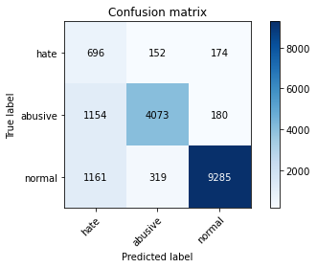

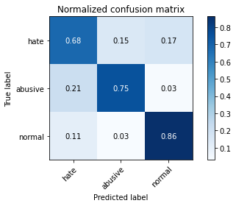

precision recall f1-score support

hate 0.23 0.68 0.35 1022

abusive 0.90 0.75 0.82 5407

normal 0.96 0.86 0.91 10765

accuracy 0.82 17194

macro avg 0.70 0.77 0.69 17194

weighted avg 0.90 0.82 0.85 17194

average eval_loss: 0.6696337445249217, accuracy: 0.8173781551704082

training 6 epoch...

237.2914297580719 seconds used......

6 training finished! average train loss: 0.10662915575282299

evaluating...

Confusion matrix, without normalization

[[ 693 189 140]

[ 974 4280 153]

[1636 333 8796]]

Normalized confusion matrix

[[0.67808219 0.18493151 0.1369863 ]

[0.18013686 0.79156649 0.02829665]

[0.15197399 0.03093358 0.81709243]]

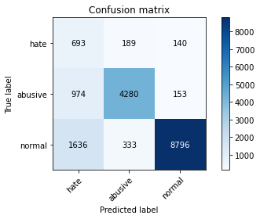

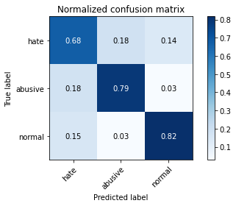

precision recall f1-score support

hate 0.21 0.68 0.32 1022

abusive 0.89 0.79 0.84 5407

normal 0.97 0.82 0.89 10765

accuracy 0.80 17194

macro avg 0.69 0.76 0.68 17194

weighted avg 0.90 0.80 0.84 17194

average eval_loss: 0.8850782919740088, accuracy: 0.8008026055600791

training 7 epoch...

237.231369972229 seconds used......

7 training finished! average train loss: 0.08900366525394889

evaluating...

Confusion matrix, without normalization

[[ 700 189 133]

[ 958 4290 159]

[1853 320 8592]]

Normalized confusion matrix

[[0.68493151 0.18493151 0.13013699]

[0.17717773 0.79341594 0.02940633]

[0.17213191 0.02972596 0.79814213]]

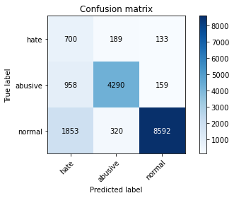

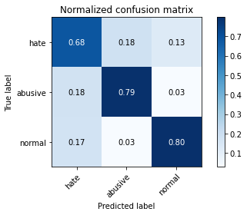

precision recall f1-score support

hate 0.20 0.68 0.31 1022

abusive 0.89 0.79 0.84 5407

normal 0.97 0.80 0.87 10765

accuracy 0.79 17194

macro avg 0.69 0.76 0.67 17194

weighted avg 0.90 0.79 0.83 17194

average eval_loss: 1.0179446419311124, accuracy: 0.7899267186227754

training 8 epoch...

237.18641996383667 seconds used......

8 training finished! average train loss: 0.07618394822883998

evaluating...

Confusion matrix, without normalization

[[ 663 172 187]

[ 974 4241 192]

[1077 304 9384]]

Normalized confusion matrix

[[0.64872798 0.16829746 0.18297456]

[0.18013686 0.78435362 0.03550952]

[0.10004645 0.02823967 0.87171389]]

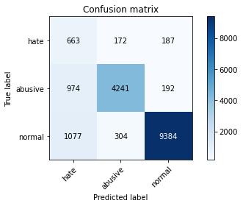

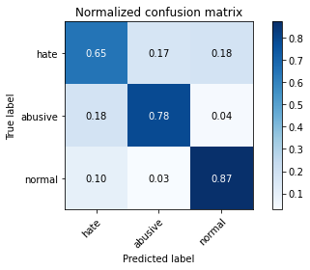

precision recall f1-score support

hate 0.24 0.65 0.35 1022

abusive 0.90 0.78 0.84 5407

normal 0.96 0.87 0.91 10765

accuracy 0.83 17194

macro avg 0.70 0.77 0.70 17194

weighted avg 0.90 0.83 0.86 17194

average eval_loss: 0.8909390522630717, accuracy: 0.8309875537978365

training 9 epoch...

237.4983251094818 seconds used......

9 training finished! average train loss: 0.07129542589209696

evaluating...

Confusion matrix, without normalization

[[ 624 251 147]

[ 697 4526 184]

[1407 458 8900]]

Normalized confusion matrix

[[0.61056751 0.24559687 0.14383562]

[0.12890697 0.83706307 0.03402996]

[0.13070135 0.04254529 0.82675337]]

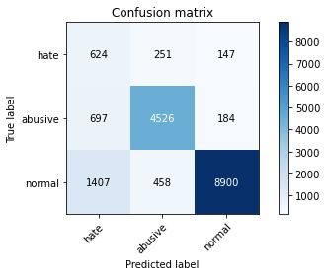

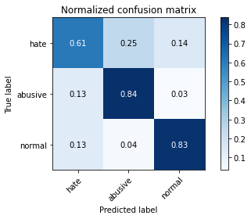

precision recall f1-score support

hate 0.23 0.61 0.33 1022

abusive 0.86 0.84 0.85 5407

normal 0.96 0.83 0.89 10765

accuracy 0.82 17194

macro avg 0.69 0.76 0.69 17194

weighted avg 0.89 0.82 0.84 17194

average eval_loss: 0.9383118425019432, accuracy: 0.8171455158776317

training 10 epoch...

237.2439215183258 seconds used......

10 training finished! average train loss: 0.06530227075143281

evaluating...

Confusion matrix, without normalization

[[ 669 176 177]

[1013 4197 197]

[1123 346 9296]]

Normalized confusion matrix

[[0.65459883 0.17221135 0.17318982]

[0.18734973 0.77621602 0.03643425]

[0.10431955 0.0321412 0.86353925]]

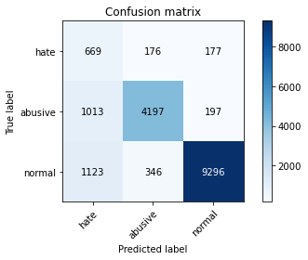

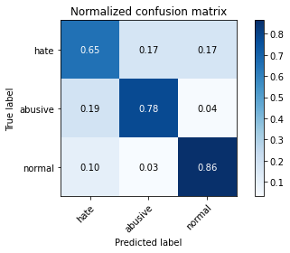

precision recall f1-score support

hate 0.24 0.65 0.35 1022

abusive 0.89 0.78 0.83 5407

normal 0.96 0.86 0.91 10765

accuracy 0.82 17194

macro avg 0.70 0.76 0.70 17194

weighted avg 0.90 0.82 0.85 17194

average eval_loss: 0.910865861455623, accuracy: 0.8236594160753752

2 run

training 1 epoch...

237.39769649505615 seconds used......

1 training finished! average train loss: 0.605285312568361

evaluating...

Confusion matrix, without normalization

[[ 615 218 189]

[ 614 4621 172]

[ 703 309 9753]]

Normalized confusion matrix

[[0.60176125 0.21330724 0.18493151]

[0.1135565 0.85463288 0.03181062]

[0.06530423 0.02870413 0.90599164]]

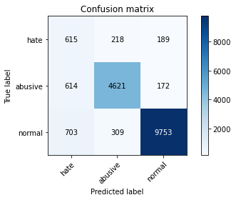

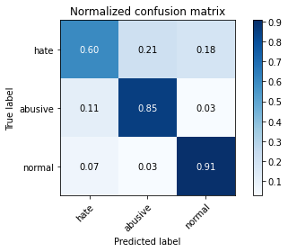

precision recall f1-score support

hate 0.32 0.60 0.42 1022

abusive 0.90 0.85 0.88 5407

normal 0.96 0.91 0.93 10765

accuracy 0.87 17194

macro avg 0.73 0.79 0.74 17194

weighted avg 0.90 0.87 0.89 17194

average eval_loss: 0.3828861840155929, accuracy: 0.8717575898569269

training 2 epoch...

237.29730105400085 seconds used......

2 training finished! average train loss: 0.44300124089551024

evaluating...

Confusion matrix, without normalization

[[ 823 114 85]

[1415 3919 73]

[2436 274 8055]]

Normalized confusion matrix

[[0.80528376 0.11154599 0.08317025]

[0.2616978 0.72480118 0.01350102]

[0.2262889 0.02545286 0.74825824]]

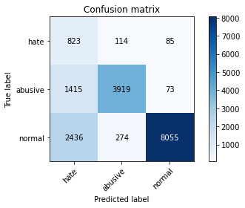

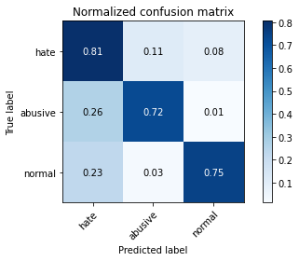

precision recall f1-score support

hate 0.18 0.81 0.29 1022

abusive 0.91 0.72 0.81 5407

normal 0.98 0.75 0.85 10765

accuracy 0.74 17194

macro avg 0.69 0.76 0.65 17194

weighted avg 0.91 0.74 0.80 17194

average eval_loss: 0.6689679213734561, accuracy: 0.7442712574153775

training 3 epoch...

237.14690446853638 seconds used......

3 training finished! average train loss: 0.3272140143821794

evaluating...

Confusion matrix, without normalization

[[ 666 184 172]

[ 868 4392 147]

[1047 295 9423]]

Normalized confusion matrix

[[0.65166341 0.18003914 0.16829746]

[0.16053264 0.81228038 0.02718698]

[0.09725964 0.02740362 0.87533674]]

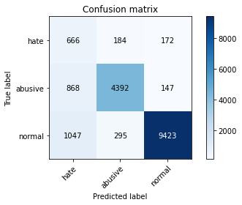

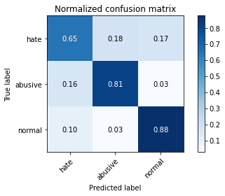

precision recall f1-score support

hate 0.26 0.65 0.37 1022

abusive 0.90 0.81 0.85 5407

normal 0.97 0.88 0.92 10765

accuracy 0.84 17194

macro avg 0.71 0.78 0.71 17194

weighted avg 0.90 0.84 0.87 17194

average eval_loss: 0.47981015601476956, accuracy: 0.842212399674305

training 4 epoch...

237.1136074066162 seconds used......

4 training finished! average train loss: 0.22627761798572324

evaluating...

Confusion matrix, without normalization

[[ 691 194 137]

[ 928 4358 121]

[1858 377 8530]]

Normalized confusion matrix

[[0.67612524 0.18982387 0.13405088]

[0.17162937 0.80599223 0.0223784 ]

[0.17259638 0.0350209 0.79238272]]

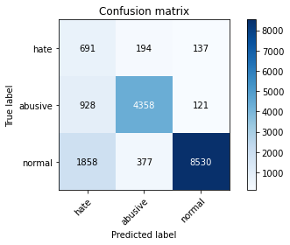

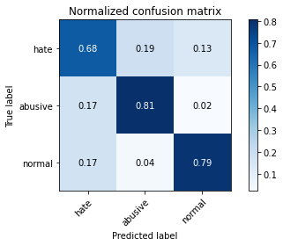

precision recall f1-score support

hate 0.20 0.68 0.31 1022

abusive 0.88 0.81 0.84 5407

normal 0.97 0.79 0.87 10765

accuracy 0.79 17194

macro avg 0.68 0.76 0.67 17194

weighted avg 0.90 0.79 0.83 17194

average eval_loss: 0.6791934465686249, accuracy: 0.7897522391531929

training 5 epoch...

237.16073083877563 seconds used......

5 training finished! average train loss: 0.14433823088625483

evaluating...

Confusion matrix, without normalization

[[ 761 142 119]

[1304 3983 120]

[1929 303 8533]]

Normalized confusion matrix

[[0.7446184 0.13894325 0.11643836]

[0.24116886 0.73663769 0.02219345]

[0.17919183 0.02814677 0.7926614 ]]

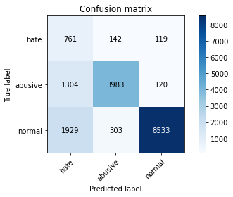

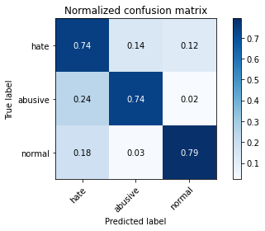

precision recall f1-score support

hate 0.19 0.74 0.30 1022

abusive 0.90 0.74 0.81 5407

normal 0.97 0.79 0.87 10765

accuracy 0.77 17194

macro avg 0.69 0.76 0.66 17194

weighted avg 0.90 0.77 0.82 17194

average eval_loss: 0.8321015438801327, accuracy: 0.7721879725485634

training 6 epoch...

237.23560166358948 seconds used......

6 training finished! average train loss: 0.11001667135624262

evaluating...

Confusion matrix, without normalization

[[ 642 215 165]

[ 859 4405 143]

[1160 434 9171]]

Normalized confusion matrix

[[0.62818004 0.21037182 0.16144814]

[0.15886813 0.81468467 0.0264472 ]

[0.10775662 0.04031584 0.85192754]]

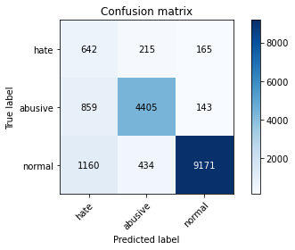

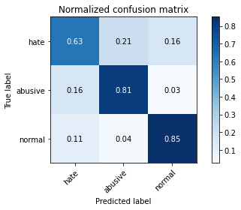

precision recall f1-score support

hate 0.24 0.63 0.35 1022

abusive 0.87 0.81 0.84 5407

normal 0.97 0.85 0.91 10765

accuracy 0.83 17194

macro avg 0.69 0.76 0.70 17194

weighted avg 0.89 0.83 0.85 17194

average eval_loss: 0.72542967048452, accuracy: 0.8269163661742468

training 7 epoch...

237.25197911262512 seconds used......

7 training finished! average train loss: 0.08649067554946643

evaluating...

Confusion matrix, without normalization

[[ 697 207 118]

[ 959 4333 115]

[2138 422 8205]]

Normalized confusion matrix

[[0.68199609 0.20254403 0.11545988]

[0.17736268 0.8013686 0.02126873]

[0.1986066 0.03920111 0.76219229]]

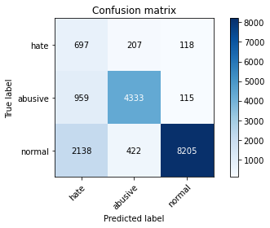

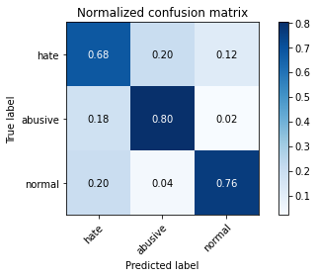

precision recall f1-score support

hate 0.18 0.68 0.29 1022

abusive 0.87 0.80 0.84 5407

normal 0.97 0.76 0.85 10765

accuracy 0.77 17194

macro avg 0.68 0.75 0.66 17194

weighted avg 0.89 0.77 0.82 17194

average eval_loss: 1.0808194663592203, accuracy: 0.7697452599744097

training 8 epoch...

237.1979877948761 seconds used......

8 training finished! average train loss: 0.0679443857220525

evaluating...

Confusion matrix, without normalization

[[ 672 179 171]

[1206 4024 177]

[1238 361 9166]]

Normalized confusion matrix

[[0.65753425 0.17514677 0.16731898]

[0.2230442 0.74422045 0.03273534]

[0.11500232 0.0335346 0.85146307]]

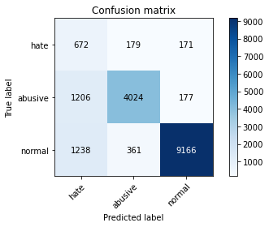

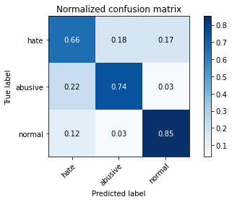

precision recall f1-score support

hate 0.22 0.66 0.32 1022

abusive 0.88 0.74 0.81 5407

normal 0.96 0.85 0.90 10765

accuracy 0.81 17194

macro avg 0.69 0.75 0.68 17194

weighted avg 0.89 0.81 0.84 17194

average eval_loss: 0.882981531701029, accuracy: 0.8062114691171339

training 9 epoch...

237.40817975997925 seconds used......

9 training finished! average train loss: 0.0673834764460127

evaluating...

Confusion matrix, without normalization

[[ 705 169 148]

[1108 4132 167]

[1656 327 8782]]

Normalized confusion matrix

[[0.68982387 0.16536204 0.14481409]

[0.20491955 0.76419456 0.03088589]

[0.15383186 0.03037622 0.81579192]]

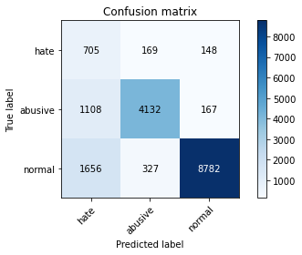

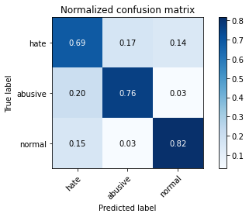

precision recall f1-score support

hate 0.20 0.69 0.31 1022

abusive 0.89 0.76 0.82 5407

normal 0.97 0.82 0.88 10765

accuracy 0.79 17194

macro avg 0.69 0.76 0.67 17194

weighted avg 0.90 0.79 0.83 17194

average eval_loss: 1.0037359240361987, accuracy: 0.7920786320809585

training 10 epoch...

237.3648076057434 seconds used......

10 training finished! average train loss: 0.05288655867704987

evaluating...

Confusion matrix, without normalization

[[ 653 220 149]

[ 800 4468 139]

[1437 451 8877]]

Normalized confusion matrix

[[0.63894325 0.21526419 0.14579256]

[0.14795635 0.82633623 0.02570742]

[0.13348816 0.04189503 0.82461681]]

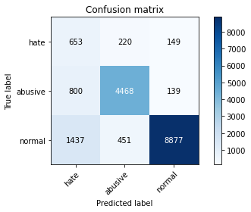

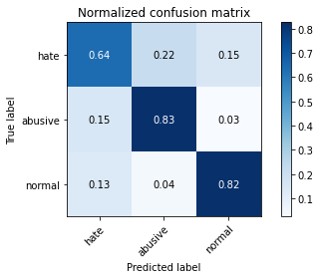

precision recall f1-score support

hate 0.23 0.64 0.33 1022

abusive 0.87 0.83 0.85 5407

normal 0.97 0.82 0.89 10765

accuracy 0.81 17194

macro avg 0.69 0.76 0.69 17194

weighted avg 0.89 0.81 0.84 17194

average eval_loss: 0.9833313915066334, accuracy: 0.8141212050715366

3 run

training 1 epoch...

237.54765343666077 seconds used......

1 training finished! average train loss: 0.6150609381648272

evaluating...

Confusion matrix, without normalization

[[ 699 187 136]

[ 744 4543 120]

[1251 342 9172]]

Normalized confusion matrix

[[0.68395303 0.18297456 0.13307241]

[0.13759941 0.84020714 0.02219345]

[0.11620994 0.03176962 0.85202044]]

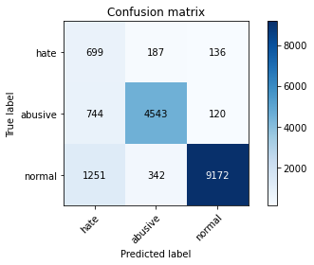

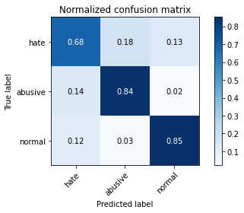

precision recall f1-score support

hate 0.26 0.68 0.38 1022

abusive 0.90 0.84 0.87 5407

normal 0.97 0.85 0.91 10765

accuracy 0.84 17194

macro avg 0.71 0.79 0.72 17194

weighted avg 0.91 0.84 0.86 17194

average eval_loss: 0.4830317738357671, accuracy: 0.8383156915202977

training 2 epoch...

237.39268827438354 seconds used......

2 training finished! average train loss: 0.4393227523693113

evaluating...

Confusion matrix, without normalization

[[ 710 191 121]

[ 825 4486 96]

[1562 362 8841]]

Normalized confusion matrix

[[0.69471624 0.18688845 0.1183953 ]

[0.15257999 0.82966525 0.01775476]

[0.14509986 0.0336275 0.82127264]]

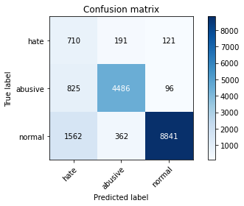

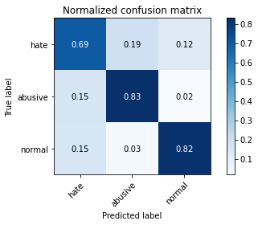

precision recall f1-score support

hate 0.23 0.69 0.34 1022

abusive 0.89 0.83 0.86 5407

normal 0.98 0.82 0.89 10765

accuracy 0.82 17194

macro avg 0.70 0.78 0.70 17194

weighted avg 0.90 0.82 0.85 17194

average eval_loss: 0.5201210240465264, accuracy: 0.816389438176108

training 3 epoch...

237.31255388259888 seconds used......

3 training finished! average train loss: 0.3210507945386739

evaluating...

Confusion matrix, without normalization

[[ 744 163 115]

[1098 4220 89]

[1922 318 8525]]

Normalized confusion matrix

[[0.72798434 0.15949119 0.11252446]

[0.20307009 0.78046976 0.01646014]

[0.17854157 0.02954018 0.79191825]]

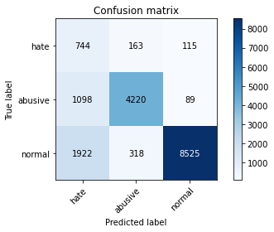

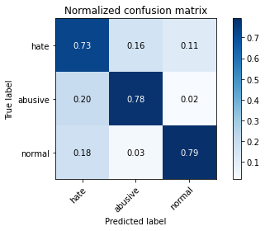

precision recall f1-score support

hate 0.20 0.73 0.31 1022

abusive 0.90 0.78 0.83 5407

normal 0.98 0.79 0.87 10765

accuracy 0.78 17194

macro avg 0.69 0.77 0.67 17194

weighted avg 0.91 0.78 0.83 17194

average eval_loss: 0.6325937580317259, accuracy: 0.7845178550657206

training 4 epoch...

237.47852110862732 seconds used......

4 training finished! average train loss: 0.21533581404683955

evaluating...

Confusion matrix, without normalization

[[ 711 162 149]

[1155 4079 173]

[1524 263 8978]]

Normalized confusion matrix

[[0.69569472 0.15851272 0.14579256]

[0.21361198 0.75439245 0.03199556]

[0.1415699 0.02443103 0.83399907]]

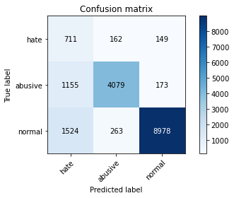

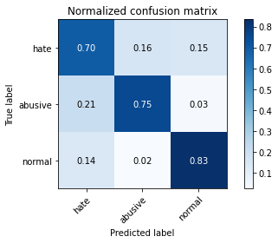

precision recall f1-score support

hate 0.21 0.70 0.32 1022

abusive 0.91 0.75 0.82 5407

normal 0.97 0.83 0.89 10765

accuracy 0.80 17194

macro avg 0.69 0.76 0.68 17194

weighted avg 0.90 0.80 0.84 17194

average eval_loss: 0.6537407632224088, accuracy: 0.800744445736885

training 5 epoch...

237.4136209487915 seconds used......

5 training finished! average train loss: 0.13889749877945295

evaluating...

Confusion matrix, without normalization

[[ 594 268 160]

[ 643 4569 195]

[1263 359 9143]]

Normalized confusion matrix

[[0.58121331 0.26223092 0.15655577]

[0.11891992 0.84501572 0.03606436]

[0.11732466 0.03334882 0.84932652]]

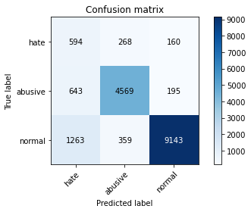

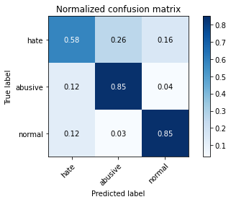

precision recall f1-score support

hate 0.24 0.58 0.34 1022

abusive 0.88 0.85 0.86 5407

normal 0.96 0.85 0.90 10765

accuracy 0.83 17194

macro avg 0.69 0.76 0.70 17194

weighted avg 0.89 0.83 0.86 17194

average eval_loss: 0.6944098351804843, accuracy: 0.8320344306153309

training 6 epoch...

237.4123933315277 seconds used......

6 training finished! average train loss: 0.10520583179907592

evaluating...

Confusion matrix, without normalization

[[ 621 247 154]

[ 758 4510 139]

[1171 472 9122]]

Normalized confusion matrix

[[0.60763209 0.24168297 0.15068493]

[0.14018864 0.83410394 0.02570742]

[0.10877845 0.0438458 0.84737575]]

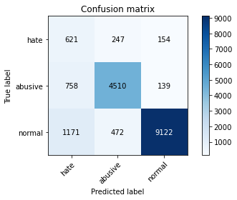

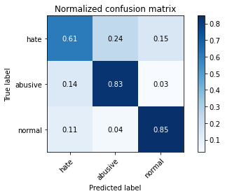

precision recall f1-score support

hate 0.24 0.61 0.35 1022

abusive 0.86 0.83 0.85 5407

normal 0.97 0.85 0.90 10765

accuracy 0.83 17194

macro avg 0.69 0.76 0.70 17194

weighted avg 0.89 0.83 0.85 17194

average eval_loss: 0.7620468266254161, accuracy: 0.8289519599860417

training 7 epoch...

237.35154247283936 seconds used......

7 training finished! average train loss: 0.09071003781940629

evaluating...

Confusion matrix, without normalization

[[ 642 234 146]

[ 721 4517 169]

[1440 363 8962]]

Normalized confusion matrix

[[0.62818004 0.22896282 0.14285714]

[0.13334566 0.83539856 0.03125578]

[0.13376684 0.03372039 0.83251277]]

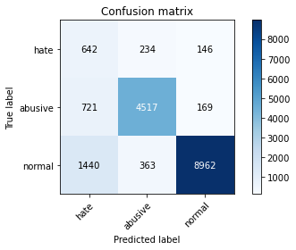

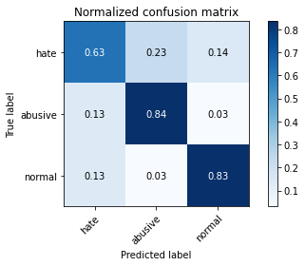

precision recall f1-score support

hate 0.23 0.63 0.34 1022

abusive 0.88 0.84 0.86 5407

normal 0.97 0.83 0.89 10765

accuracy 0.82 17194

macro avg 0.69 0.77 0.70 17194

weighted avg 0.90 0.82 0.85 17194

average eval_loss: 0.8221240293256246, accuracy: 0.8212748633244155

training 8 epoch...

237.44609260559082 seconds used......

8 training finished! average train loss: 0.07401226742879506

evaluating...

Confusion matrix, without normalization

[[ 651 190 181]

[ 947 4253 207]

[1146 328 9291]]

Normalized confusion matrix

[[0.6369863 0.18590998 0.17710372]

[0.17514333 0.78657296 0.03828371]

[0.10645611 0.03046911 0.86307478]]

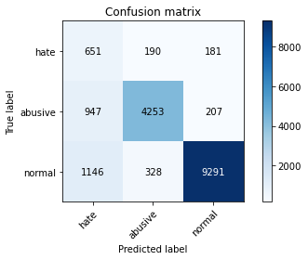

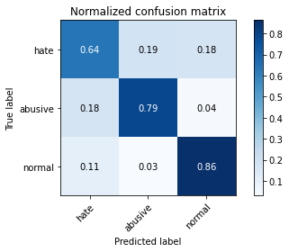

precision recall f1-score support

hate 0.24 0.64 0.35 1022

abusive 0.89 0.79 0.84 5407

normal 0.96 0.86 0.91 10765

accuracy 0.83 17194

macro avg 0.70 0.76 0.70 17194

weighted avg 0.90 0.83 0.85 17194

average eval_loss: 0.9052600847226893, accuracy: 0.8255786902407817

training 9 epoch...

237.52903580665588 seconds used......

9 training finished! average train loss: 0.06743177739455539

evaluating...

Confusion matrix, without normalization

[[ 706 179 137]

[1146 4098 163]

[1603 369 8793]]

Normalized confusion matrix

[[0.69080235 0.17514677 0.13405088]

[0.21194748 0.75790642 0.03014611]

[0.1489085 0.03427775 0.81681375]]

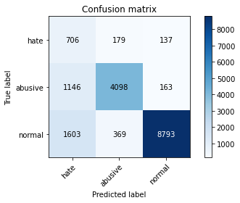

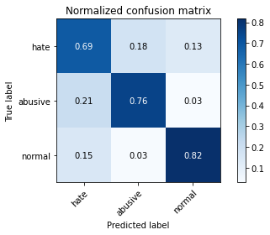

precision recall f1-score support

hate 0.20 0.69 0.32 1022

abusive 0.88 0.76 0.82 5407

normal 0.97 0.82 0.89 10765

accuracy 0.79 17194

macro avg 0.68 0.76 0.67 17194

weighted avg 0.89 0.79 0.83 17194

average eval_loss: 1.093672656421658, accuracy: 0.7907991159706874

training 10 epoch...

237.40771746635437 seconds used......

10 training finished! average train loss: 0.05636071033884732

evaluating...

Confusion matrix, without normalization

[[ 657 223 142]

[ 829 4406 172]

[1317 398 9050]]

Normalized confusion matrix

[[0.64285714 0.21819961 0.13894325]

[0.15331977 0.81486961 0.03181062]

[0.12234092 0.03697167 0.84068741]]

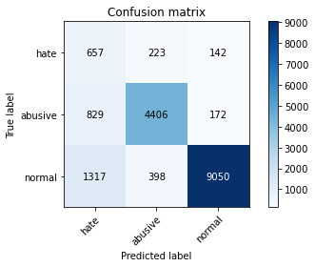

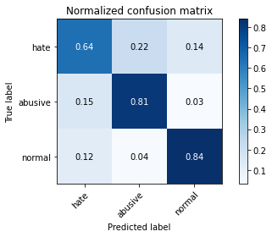

precision recall f1-score support

hate 0.23 0.64 0.34 1022

abusive 0.88 0.81 0.84 5407

normal 0.97 0.84 0.90 10765

accuracy 0.82 17194

macro avg 0.69 0.77 0.70 17194

weighted avg 0.89 0.82 0.85 17194

average eval_loss: 1.0054156087723365, accuracy: 0.8208095847388623

4 run

training 1 epoch...

237.40288019180298 seconds used......

1 training finished! average train loss: 0.6280698767835884

evaluating...

Confusion matrix, without normalization

[[ 628 232 162]

[ 540 4725 142]

[ 925 367 9473]]

Normalized confusion matrix

[[0.61448141 0.22700587 0.15851272]

[0.09987054 0.87386721 0.02626225]

[0.08592661 0.03409196 0.87998142]]

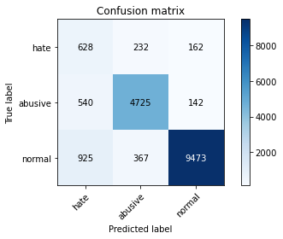

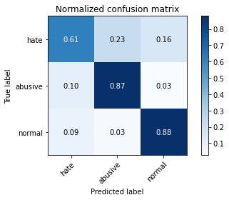

precision recall f1-score support

hate 0.30 0.61 0.40 1022

abusive 0.89 0.87 0.88 5407

normal 0.97 0.88 0.92 10765

accuracy 0.86 17194

macro avg 0.72 0.79 0.74 17194

weighted avg 0.90 0.86 0.88 17194

average eval_loss: 0.4105721267156823, accuracy: 0.8622775386762824

training 2 epoch...

237.32021760940552 seconds used......

2 training finished! average train loss: 0.45173215117667115

evaluating...

Confusion matrix, without normalization

[[ 602 209 211]

[ 588 4635 184]

[ 694 312 9759]]

Normalized confusion matrix

[[0.5890411 0.20450098 0.20645793]

[0.10874792 0.85722212 0.03402996]

[0.06446818 0.02898281 0.906549 ]]

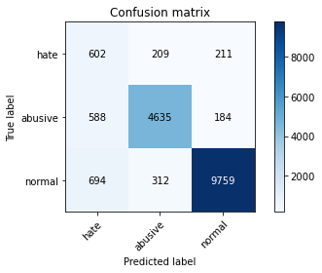

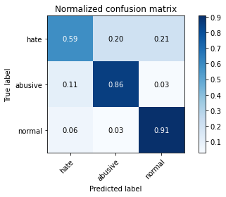

precision recall f1-score support

hate 0.32 0.59 0.41 1022

abusive 0.90 0.86 0.88 5407

normal 0.96 0.91 0.93 10765

accuracy 0.87 17194

macro avg 0.73 0.78 0.74 17194

weighted avg 0.90 0.87 0.88 17194

average eval_loss: 0.37274979536616526, accuracy: 0.8721647086192857

training 3 epoch...

237.292316198349 seconds used......

3 training finished! average train loss: 0.34138609667394826

evaluating...

Confusion matrix, without normalization

[[ 679 183 160]

[ 779 4472 156]

[1280 378 9107]]

Normalized confusion matrix

[[0.66438356 0.17906067 0.15655577]

[0.1440725 0.82707601 0.02885149]

[0.11890386 0.03511379 0.84598235]]

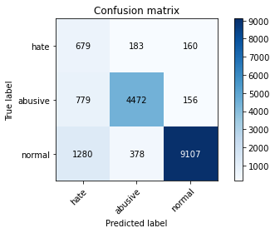

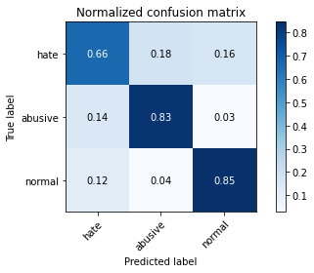

precision recall f1-score support

hate 0.25 0.66 0.36 1022

abusive 0.89 0.83 0.86 5407

normal 0.97 0.85 0.90 10765

accuracy 0.83 17194

macro avg 0.70 0.78 0.71 17194

weighted avg 0.90 0.83 0.86 17194

average eval_loss: 0.5054284228315187, accuracy: 0.8292427591020123

training 4 epoch...

237.44432759284973 seconds used......

4 training finished! average train loss: 0.22873031326966953

evaluating...

Confusion matrix, without normalization

[[ 635 208 179]

[ 770 4481 156]

[1131 412 9222]]

Normalized confusion matrix

[[0.62133072 0.2035225 0.17514677]

[0.14240799 0.82874052 0.02885149]

[0.1050627 0.03827218 0.85666512]]

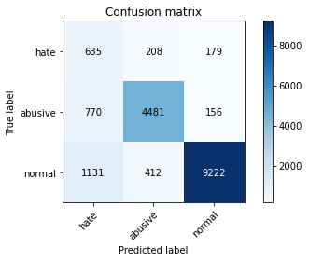

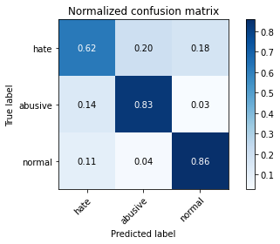

precision recall f1-score support

hate 0.25 0.62 0.36 1022

abusive 0.88 0.83 0.85 5407

normal 0.96 0.86 0.91 10765

accuracy 0.83 17194

macro avg 0.70 0.77 0.71 17194

weighted avg 0.90 0.83 0.86 17194

average eval_loss: 0.5956661652968547, accuracy: 0.8338955449575434

training 5 epoch...

237.40550303459167 seconds used......

5 training finished! average train loss: 0.1527902237444477

evaluating...

Confusion matrix, without normalization

[[ 702 203 117]

[ 921 4388 98]

[2173 405 8187]]

Normalized confusion matrix

[[0.68688845 0.19863014 0.11448141]

[0.17033475 0.8115406 0.01812465]

[0.20185787 0.03762192 0.7605202 ]]

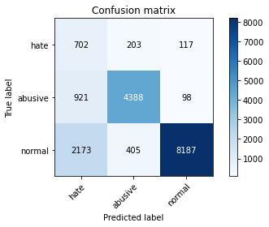

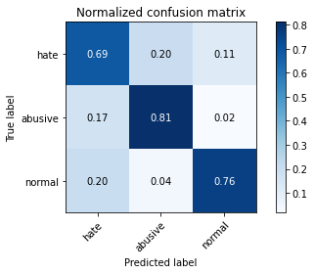

precision recall f1-score support

hate 0.18 0.69 0.29 1022

abusive 0.88 0.81 0.84 5407

normal 0.97 0.76 0.85 10765

accuracy 0.77 17194

macro avg 0.68 0.75 0.66 17194

weighted avg 0.90 0.77 0.82 17194

average eval_loss: 0.8800389269150274, accuracy: 0.7721879725485634

5 run

training 1 epoch...

237.40288019180298 seconds used......

1 training finished! average train loss: 0.6280698767835884

evaluating...

Confusion matrix, without normalization

[[ 628 232 162]

[ 540 4725 142]

[ 925 367 9473]]

Normalized confusion matrix

[[0.61448141 0.22700587 0.15851272]

[0.09987054 0.87386721 0.02626225]

[0.08592661 0.03409196 0.87998142]]





precision recall f1-score support

hate 0.30 0.61 0.40 1022

abusive 0.89 0.87 0.88 5407

normal 0.97 0.88 0.92 10765

accuracy 0.86 17194

macro avg 0.72 0.79 0.74 17194

weighted avg 0.90 0.86 0.88 17194

average eval_loss: 0.4105721267156823, accuracy: 0.8622775386762824

training 2 epoch...

237.32021760940552 seconds used......

2 training finished! average train loss: 0.45173215117667115

evaluating...

Confusion matrix, without normalization

[[ 602 209 211]

[ 588 4635 184]

[ 694 312 9759]]

Normalized confusion matrix

[[0.5890411 0.20450098 0.20645793]

[0.10874792 0.85722212 0.03402996]

[0.06446818 0.02898281 0.906549 ]]





precision recall f1-score support

hate 0.32 0.59 0.41 1022

abusive 0.90 0.86 0.88 5407

normal 0.96 0.91 0.93 10765

accuracy 0.87 17194

macro avg 0.73 0.78 0.74 17194

weighted avg 0.90 0.87 0.88 17194

average eval_loss: 0.37274979536616526, accuracy: 0.8721647086192857

training 3 epoch...

237.292316198349 seconds used......

3 training finished! average train loss: 0.34138609667394826

evaluating...

Confusion matrix, without normalization

[[ 679 183 160]

[ 779 4472 156]

[1280 378 9107]]

Normalized confusion matrix

[[0.66438356 0.17906067 0.15655577]

[0.1440725 0.82707601 0.02885149]

[0.11890386 0.03511379 0.84598235]]





precision recall f1-score support

hate 0.25 0.66 0.36 1022

abusive 0.89 0.83 0.86 5407

normal 0.97 0.85 0.90 10765

accuracy 0.83 17194

macro avg 0.70 0.78 0.71 17194

weighted avg 0.90 0.83 0.86 17194

average eval_loss: 0.5054284228315187, accuracy: 0.8292427591020123

training 4 epoch...

237.44432759284973 seconds used......

4 training finished! average train loss: 0.22873031326966953

evaluating...

Confusion matrix, without normalization

[[ 635 208 179]

[ 770 4481 156]

[1131 412 9222]]

Normalized confusion matrix

[[0.62133072 0.2035225 0.17514677]

[0.14240799 0.82874052 0.02885149]

[0.1050627 0.03827218 0.85666512]]





precision recall f1-score support

hate 0.25 0.62 0.36 1022

abusive 0.88 0.83 0.85 5407

normal 0.96 0.86 0.91 10765

accuracy 0.83 17194

macro avg 0.70 0.77 0.71 17194

weighted avg 0.90 0.83 0.86 17194

average eval_loss: 0.5956661652968547, accuracy: 0.8338955449575434

training 5 epoch...

237.40550303459167 seconds used......

5 training finished! average train loss: 0.1527902237444477

evaluating...

Confusion matrix, without normalization

[[ 702 203 117]

[ 921 4388 98]

[2173 405 8187]]

Normalized confusion matrix

[[0.68688845 0.19863014 0.11448141]

[0.17033475 0.8115406 0.01812465]

[0.20185787 0.03762192 0.7605202 ]]





precision recall f1-score support

hate 0.18 0.69 0.29 1022

abusive 0.88 0.81 0.84 5407

normal 0.97 0.76 0.85 10765

accuracy 0.77 17194

macro avg 0.68 0.75 0.66 17194

weighted avg 0.90 0.77 0.82 17194

average eval_loss: 0.8800389269150274, accuracy: 0.7721879725485634